**EFFECT OF COVID-19 ON THE UK ECONOMY COMPARED TO FRANCE**

**INTRODUCTION**

In December, an outbreak of a new disease occurred in Wuhan, China called Covid-19. Since this outbreak, Covid-19 has caused a global pandemic that has shocked the world. To suppress the health effects the United Kingdom introduced a national lockdown in March 2020 and restrictions, such as school and business closures. These restrictions had detrimental effects on the economy. The lockdown forced people to stay at home and, therefore, reduced economic activity. The United Kingdom has been heavily affected and, currently, has the most deaths and infections in Europe.

The pandemic caused a severe recession, with an unprecedented drop in GDP during the first national lockdown in 2020. As businesses and consumers adapted, subsequent lockdowns in autumn 2020 and winter 2020/21 did not lead to as severe a decline in economic activity. Numerous policies were introduced by the government and the Bank of England to support businesses and workers and mitigate at least some of the negative economic impacts of the pandemic and lockdowns. These measures were designed to keep businesses afloat and as many people as possible employed. The measures financially supported businesses, workers and the wider public during the pandemic, as well as attempting to reduce economic uncertainty. Many of the costs of the pandemic were associated with reduced economic activity, but we also cannot estimate precisely how much of this reduction was caused by the lockdowns and how much would have been caused anyway by people voluntarily reducing their social contact.

As the COVID-19 virus spread rapidly and lockdown orders were imposed across the globe, trade flows came to a halt. In April 2020, the value of France’s total exports declined by 78% and imports declined by 70% in year-on-year terms. The trade collapse raised questions about the fragility of global value chains (GVCs) and pandemic-induced deglobalization. However, concerns about the survival of GVCs subsided when global trade flows returned to their pre-pandemic levels by the end of 2020. Fueled by economic recovery in advanced economies and shifts in consumption patterns away from contact-intensive service industries, demand for manufactured goods has rebounded quickly. Nevertheless, many questions about the margins of trade adjustment and firm-level factors that contributed to the collapse and the subsequent rebound of international trade remain unanswered.

The goals of this research are to analyze the effect of covid 19 on the UK Economy compared to France's Economy and to discuss the way Covid 19 affected the country(s) GDP. Two main research questions are as follows: What are the economic costs of the pandemic on the British economy compared to France? Did the British Government introduce appropriate policies during the pandemic and lockdown?

**LITERATURE REVIEW**

The COVID-19 epidemic has had a significant impact on the UK economy, posing hitherto unheard-of difficulties for both businesses and households. To compare the effects of COVID-19 on the UK and France, we considered a number of economic factors, including GDP, stock price, and inflation.

According to "Inflation and price indices - Office for National Statistics, 2021," the rate of inflation is the change in prices for goods and services over time. Inflation: Prices on the Rise states that "Inflation measures how much more expensive a set of goods and services have become over a certain period, usually a year" (Inflation: Prices on the Rise, 2022). Consumer price inflation, producer price inflation, and the house price index are other indicators of inflation and price changes.

The stock price is the current market value of a share of stock. When a publicly traded company's shares are issued, their worth is assigned a price that, ideally, reflects the company's value. The price of a stock will fluctuate in reaction to a range of reasons, including changes in the overall economy, changes in individual industries, and other considerations in this case Covid-19. (Park, 2019)

**MACHINE LEARNING**

Researchers have used classification and regression modelling to analyze the data to better understand how the pandemic has affected the UK economy. To better understand the impact of the pandemic on the UK economy, researchers have used regression modelling to analyze the data. We will discuss several of them in this section.

**RELATED WORK**

One study (Nasir et al., 2020) used a random forest classifier to predict the effects of the pandemic on UK small and medium-sized enterprises (SMEs). According to the study, SMEs in the retail and hospitality industries were the most vulnerable to the pandemic's effects. The authors also identified key determinants of SME fortitude during the pandemic, together with company size, financial performance, and access to finance.

Another study (Wang et al., 2021) used a support vector machine classifier to analyze the impact of the pandemic on the UK housing market. According to the study, the pandemic significantly affected the UK housing market, resulting in declining prices and a decline in transaction volume in some areas. The authors ultimately decided that elements like the local virus spread, and regional economic conditions had an impact on how the pandemic affected the housing market.

A third study (Zhang et al., 2022) used a neural network classifier to analyze the impact of the pandemic on consumer behaviour in the UK. According to the study, the flu epidemic significantly changed consumer behaviour, changing their spending patterns, and triggering them to start shopping online. The researchers also discovered that the pandemic had a significant impact on how consumers behaved. These factors included income, age, and occupational status.

In conclusion, classification modelling has been widely used to analyze the effects of the COVID-19 pandemic on the UK economy. These studies have shown that the pandemic has had a significant impact on various sectors of the UK economy and that the impact has been influenced by a range of factors, including regional economic conditions and individual characteristics.

**RESEARCH METHODOLOGY**

**ANALYSIS OF THE UK GPD DURING THE COVID-19 PANDEMIC COMPARED TO FRANCE**

**INTRODUCTION**

Following the Covid-19 outbreak in Wuhan, China, and the subsequent Covid-19 pandemic, the United Kingdom government has launched a few health and economic initiatives. The United Kingdom declared a state of emergency on March 23 and did not allow anybody to leave their houses until July 4, when non-essential stores and schools reopened. Many limitations were later overturned by the UK in July, although some remain in effect, such as prohibitions on big gatherings such as concerts, sporting events, and theatres. As a result, the United Kingdom was not operating at pre-pandemic levels of economic activity since some restrictions remained in place. The UK was then placed under a second lockdown on November 3, 2020, which would endure until December 2, 2020. Schools were allowed to remain open during this less severe lockdown than during the last one, although non-essential businesses such as restaurants and retail establishments were closed. This chapter will look at the economic consequences of the Covid-19 pandemic and both lockdowns.

**Coronavirus and UK GDP**

#### What is GDP?

The value of all final goods and services produced within a country over a given period (often a quarter or a whole year) is known as its Gross Domestic Product (GDP). It also calculates the entire amount of money earned from production and spent on final goods and services inside the economy. Gross domestic product (GDP) can be calculated in two different ways: at constant (or "nominal") prices and at constant (or "real") volumes.

It aids in determining the overall health of the economy and allows for comparisons with other countries. It includes;

* the value of all goods and services
* spending across households, businesses, charities, and government
* all income, including wages, profits, and trade.

The UK's GDP declined by 2.7% in the first quarter of 1974, which was the biggest quarterly decline between 1955 and 2020 according to ONS figures.

Estimates from the Bank of England indicate that, before 1955, the GDP experienced the following major annual swings:

* An 11.5% rise as the country pivoted to a wartime economy in 1939.
* A 10.1% fall during the Great Depression of 1921

The worldwide economy has taken a huge hit due to the consequences of the coronavirus (COVID-19) pandemic, the implementation of public health regulations, and the voluntary separation of people to avoid the spread of the disease. Several developed economies saw double-digit drops in GDP in the first half of 2020. Quarter 3 (July-September) 2020 saw a pick-up in activity because of loosening restrictions, but at the conclusion of Quarter 4 (October-December) 2019, the amount of GDP in most economies was still below what it had been before the coronavirus outbreak.

The current price estimates simply document the values of output, income, and spending. When we look at the output, we can see that the present price of GDP can climb if we produce more goods and services or if their prices rise. For international comparisons, the volume estimate of GDP, which removes the influence of price rises, is typically used.

The UK economy experienced the greatest loss in GDP volume over the first six months of 2020, dropping up to 14% in April 2020 (Figure 1). The 8.6% decline in volume GDP as of the end of the third quarter of 2020 compared to the pre-coronavirus level (quarterly GDP predictions as of the end of the fourth quarter of 2019) is the largest among the G7 countries (Figure 2), surpassing even France.

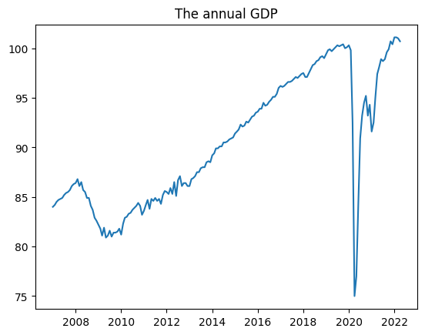

Figure 1: Annual GDP of the UK economy

Nonetheless, volume estimates show a larger GDP gap than current prices do. For instance, the current price gap in the UK is 3.4%, which is lower than the gaps in Canada, Italy, and Germany.

Since this trend does not appear to have occurred in any of the other G7 countries, it suggests that the cost of GDP in the UK shifted significantly during the coronavirus pandemic. The question of whether these GDP estimates are comparable thus arises. Current price and volume estimates of GDP across countries are compared, and other methods of GDP calculation are discussed.

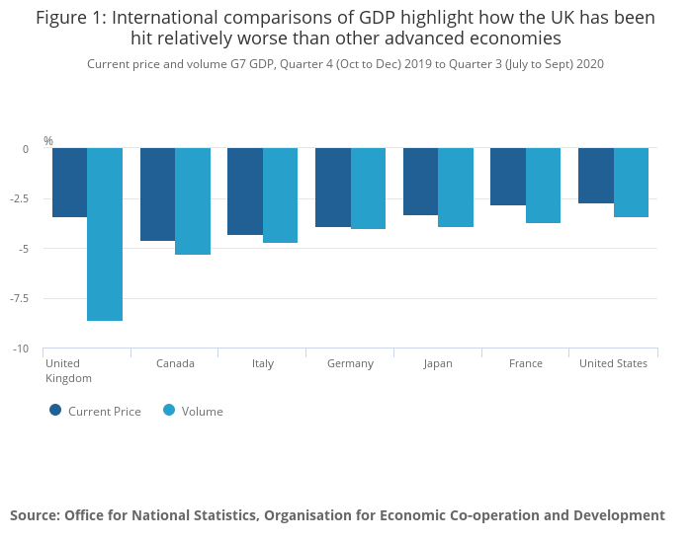

*Source: (Gooding, 2021; Leaker, 2021; McAuley, 2021)*

Figure 2: International comparisons of GDP highlight how the UK has been hit relatively worse than other advanced economies.

Current price and volume G7 GDP, Quarter 4 (Oct to Dec) 2019 to Quarter 3 (July to Sept) 2020

**SNAPSHOT OF INDICATORS OF MACROECONOMIC PERFORMANCE BETWEEN MARCH 2020 AND THE PRESENT DAY**

For a decade before the epidemic hit, the United Kingdom's economy was bouncing back from the Great Recession that the 2008 Global Financial Crisis triggered. Figure 1 shows that the UK economy was at £ 92.5 million at the end of the first quarter of 2020, before the Covid-19 outbreak and UK lockdown occurred. The second quarter saw the worst of the first wave of Covid-19 cases and the tightest lockdown restrictions, leading to a 19% drop in GDP to £84.3 million for the UK. The United Kingdom eased several restrictions in the third quarter, allowing enterprises that were previously deemed unnecessary to function. The GDP picked up and grew by 16.1%, reaching £94.5 million. In the final three months of 2020, annual GDP growth was 1.0%.

Businesses closing and employees being laid off are both possible outcomes of a decline in GDP. Surprisingly, considering the steep decline in GDP, the rate of joblessness has not skyrocketed. This is because government programs like the Coronavirus Job Retention Scheme have been successful in preventing the loss of employment and company. If a company keeps an employee on the payroll and allows them time off during a pandemic, that employee will continue to receive income. Up to £2500, or 80% of the worker's monthly pay, would be paid by the government if a British company placed an employee on furlough. This was one of the primary actions taken by the British government during the pandemic. It provided a means of financial support and employment stability.

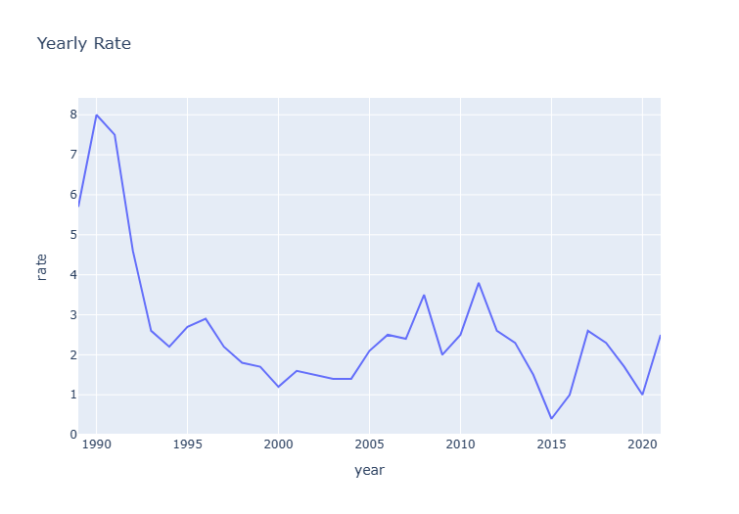

Fig 3: Annual Inflation Rate

According to Figure 4, the CPIH (Consumer Prices Index including owner occupiers' housing costs) inflation rate in the UK was 1.8% at the beginning of 2020. The rate of inflation in the United Kingdom decreased to 0.8% in December. This drop in inflation was anticipated since a weakening GDP leads to reduced expenditure, leaving the economy vulnerable to deflationary forces. Figure 1 shows that the UK economy has suffered greatly because of the Covid-19 outbreak and the two lockdowns. The unemployment and inflation rates, however, have not shifted to the same extent. Variations in light of GDP growth.

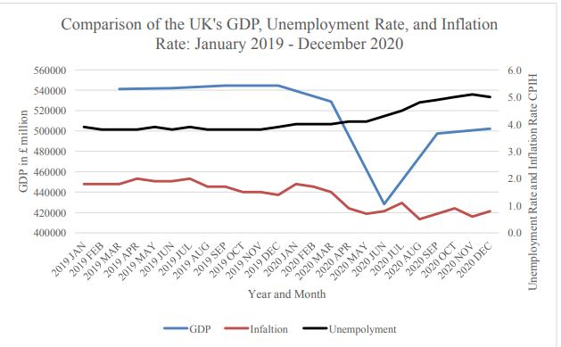

Source: (Gooding, 2021; Leaker, 2021; McAuley, 2021).

Fig 4: Comparison of the UK's GDP, Unemployment Rate, and Inflation Rate from January 2019 to December 2020.

**PREDICTED GROSS DOMESTIC PRODUCT GROWTH DURING THE COVID-19 PANDEMIC**

As expected, economic activity dropped when the UK government enforced the lockdown and told citizens to stay indoors. The economy shrank by 15% in the first 30 days of the shutdown (Miles et al., 2020). Manufacturing, purchasing, and selling are all examples of economic activity. Since GDP is a proxy for economic activity, a sharp drop in GDP would follow a drop-in economic activity. In the second quarter of 2020, the Bank of England predicted that GDP will have dropped by 20% (Brewer et al., 2020). Due to the dynamic nature of pandemics, quarterly GDP numbers are preferable to annual GDP figures when analyzing the impact on GDP. As a result, quarterly data is necessary to examine the impact of these adjustments on the data.

Many government agencies predict that the UK's GDP will fall dramatically both during and after the lockdown, looking at what would have happened in the absence of the lockdown might help put the impact of the shutdown and the predicted drop in GDP into perspective. Using a computable general equilibrium model, Keogh-Brown et al. (2019) analyze the economic effects of the Covid-19 epidemic on the United Kingdom and simulate three different scenarios. (2020) In first, there is no policy in place to prevent the spread of illnesses and associated direct healthcare expenses. They have variables like sick leave, hospitalization, critical care unit admission, and death that take people out of the labour force (Keogh-Brown et al., 2020). The model predicted that this would have a negative impact on GDP in the United Kingdom of £39.6 billion, or 1.73 per cent of the GDP (Keogh-Brown et al., 2020). Work absence from hospitalized patients is responsible for the majority of the GDP loss, totalling £30.8bn. The economic impact of deaths was estimated at £4.7 billion, hospitalizations at £2.8 billion, and intensive care unit admissions at £0.6 billion (Keogh Brown et al., 2020). This evidence suggests that sickness-related job absences are more important than deaths in causing a decline in GDP. The overall economic cost associated with these high-profile deaths is not accounted for in this model, but it is estimated at $358,000 (Keogh-Brown et al., 2020). Loss of future productivity is one way to quantify these economic consequences, which are greatest for people who pass away between the ages of 18 and 65.

Direct health care expenses from Scenario 1 are included in Scenario 2, along with pandemic mitigation techniques for 12 weeks. Some of these measures include isolating infected households for 14 days, providing extra protection to those over the age of 70, isolating themselves socially, and closing schools and businesses (Keogh-Brown et al., 2020). Costing an estimated £308 billion (13.5 per cent of GDP), this scenario would have a significant impact on the UK's real GDP and cause a severe economic downturn (Keogh-Brown et al., 2020). Compared to health insurance, the non-health policy was more expensive. It costs the UK £264.1 billion for non-health-related policies but only £53.1 billion for health-related ones (Keogh-Brown et al., 2020). School closures, which cost £66.1bn for 12 weeks of schools being closed, and business closures, which cost £200.9bn for 12 weeks of business closures, are the two largest non-health-related economies (Keogh-Brown et al., 2020). The model predicts that within 12 weeks, the economic cost of the policy of pandemic mitigation will have climbed dramatically, by a whopping 777%. The rules, though, did help cut deaths by about one-third. As was indicated in the baseline case, the larger economic effects of death are not accounted for in this model. The third and last case involves direct health costs and the prevention of a pandemic. Policies from the Pandemic Mitigation Scenario are incorporated into this one. There may be more than one wave of illnesses, therefore policies may need to be implemented for longer than 12 weeks and used and discarded numerous times throughout 2020 (Keogh-Brown et al., 2020). Based on the data provided by Keogh-Brown et al. (2020), this scenario predicts that the policies in place from March 2020 through the end of the year will be in effect for 74% of the time or 207 days. The monetary damage from this scenario totals £668.4bn (or about 29.2% of the UK GDP) (Keogh-Brown et al., 2020). Once again, the cost of non-health-related policies is substantially higher than the cost of health-related policies in this case. The model predicts a £632.9 billion loss in GDP as a result of non-health related measures; this includes a £166.2 billion loss in GDP as a result of school closures and a £386.6 billion loss in GDP as a result of business closures. The model shows that the longer these policies stay in place, the more destructive they are to the UK's GDP and, by extension, the overall health of the UK economy, even though the number of lives saved remains constant.

Using this research as a guide, we can anticipate a decline in the UK GDP of 13.5%-29.2%. This is because, since March, the UK has not only implemented measures lasting longer than 12 weeks but has also not kept schools and businesses closed for 74% of the time. But as of this writing on the 2nd of December 2020, the United Kingdom has just emerged from a second lockdown that lasted the entire month of November 2020. During this time, businesses were shuttered but schools were not. Since this lockdown did not last as long or contain as stringent measures as the first, the economic impact of it will be less. The most significant non-health-related policies that result in the largest loss of GDP are those that close schools and businesses, as shown in this study. The GDP drops significantly when schools are closed because parents must take time off work to care for their children. They must give up their occupations so they may take care of their families. When companies stop operating, employment opportunities dry up and consumers spend less money on goods and services.

**GDP ANALYSIS FROM 2005 TO MARCH 2020 (PRE-PANDEMIC)**

Macroeconomic indicators in the years before the pandemic must be analyzed to reveal the state of the UK economy before the pandemic. carried out without the threat of the Covid-19 epidemic.

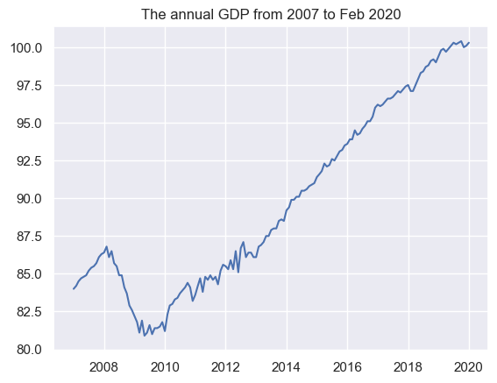

Fig 5: The Annual GDP of the UK from 2007 to 2020

With this research as a point of reference, we may anticipate how the UK would have fared in the absence of the epidemic and act accordingly. As a result, we will demonstrate how much the Covid-19 pandemic has affected GDP in the United Kingdom. GDP (Gross Domestic Product) is the market value of all final products and services produced inside the UK and is displayed monthly in Figure 5. Figure 5 demonstrates that the UK economy grew at a modest but consistent rate of 0.71 per cent annually during these quarters. After the first three months of 2008, the United Kingdom fell into its deepest economic crisis since the Great Depression. The economy's growth rate plummeted from the first to the second quarters of 2008 and 2009. GDP fell by 2.1% from the third to the fourth quarter of 2008, following a 1.6% drop in the second quarter. The Bank of England implemented quantitative easing to stimulate the UK economy and aid in economic recovery after interest rates were cut to 0.5% as a result of the Global Financial Crisis. The GDP of the United Kingdom returned to levels seen before the recession in the second quarter of 2013. Figure 5 displays the return to linear GDP growth in the UK from this quarter through the fourth quarter of 2019. This is supported by Figure 3, which shows quarterly average GDP growth of 0.5% with a little out departure from the norm. The UK imposed measures to prevent the spread of the Covid-19 pandemic beginning in the first quarter of 2020. As was noted earlier, this resulted in the closure of businesses and strict instructions for people to remain indoors. Figure 6 displays a sharp decline of 2.9% in GDP from the fourth quarter of 2019 and the first quarter of 2020.

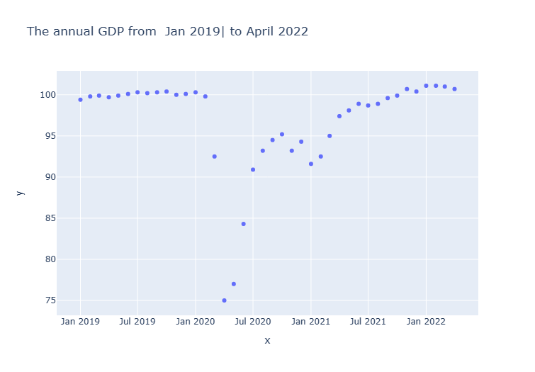.

Fig 6: The Annual GDP of the UK from Jan 2019 to April 2022

Figure 5 shows that it took the economy five years to recover from the Global Financial Crisis of 2008. Since then, the UK economy has been booming, with continuous expansion lasting through 2019. This rate of economic expansion suggests that the United Kingdom will have only modest continuous growth through 2020. After several years of austerity, the UK government raised public spending this year (Giles, 2019). Since GDP includes public expenditures, an increase in public spending would have resulted in a rise in GDP. Boosts in GDP are possible from increased public investment in capital due to efficiency and productivity gains. The United Kingdom's formal withdrawal from the European Union was a big event that took place around the end of 2020. The future of the United Kingdom is uncertain as a result of Brexit. As uncertainty increases, investment and consumption levels may have fallen as a result, thus lowering GDP. Without the pandemic, the United Kingdom's economy is projected to rise at a modest but steady rate in 2020.

**GDP ANALYSIS FROM QUARTER 1 2019 – QUARTER 1 2022**

Gross domestic product (GDP) is broken down into four areas below: consumption, investment, government, and net imports. The GDP of the United Kingdom is expected to fall from roughly 13.5% in 2019 to 29.2% in 2020 as a result of the epidemic and restrictions. The UK's GDP fell by the largest amount ever recorded because of the Covid-19 outbreak and the accompanying complementary restrictions. GDP fell from the fourth quarter of 2019 to the second quarter of 2020, as illustrated in Figure 6. GDP fell by 2.1% from the fourth quarter of 2019 and the first quarter of 2020. The GDP dropped by a record 19.0% from the first to the second quarter of 2020. After the second quarter of 2020, GDP began to rise again as the UK started easing restrictions and economic activity picked up speed. Some firms, such as those in the retail and hospitality sectors, were allowed to reopen and individuals were allowed to return to work as a result of these restrictions. (Later in this section, an examination of consumer spending will demonstrate the degree of the change in economic activity over this era). This resulted in a quarterly gain in GDP of 16.1%, the highest on record according to figures compiled by the Office of National Statistics. Then, in the final quarter of 2020, GDP grew again, this time by a percentage point of 1.0%. The UK tightened regulations in response to a rise in Covid-19 cases in November, which contributed to the current GDP downturn.

**CONCLUSION OF GDP ANALYSIS**

The Covid-19 epidemic has had a significant impact on GDP, as indicated by the 19% drop in GDP from the first to the second quarter of 2020. Substantial declines in both consumption and investment are the root causes of this drop. The government allocated funds to protect the public against Covid-19 and to aid businesses and workers. As a result, government expenditure helps keep unemployment rates low, making economic revival more manageable. The lockdown's impact on consumption was significant, and the Covid-19's effect on investment was significant because of the resulting uncertainty.

**PREDICTED CHANGES IN INFLATION DURING COVID-19 AND THE UK LOCKDOWN**

The correlation between inflation and GDP is typically linear. Inflation falls as GDP falls and rises when GDP rises. This is because when GDP declines, consumption, and demand decline, leading to lower prices. Consumption, demand, and price increase all rise in tandem with a growing GDP. Inflation is predicted to fall as a result of the 19% drop in GDP in the second quarter of 2020. The GDP drop is so severe that deflationary forces, where inflation goes below zero, may be felt in the UK. Because of the pandemic, people's needs for necessities like food and medicine have changed. At the outset of the pandemic, supply networks were also disrupted (Ebrahimy, 2020). Prices for these items will go up due to both factors, but the overall impact on inflation will depend on how they are weighed in the CPI. It is crucial to examine the basket of products used to calculate CPI in light of the altered purchasing patterns brought on by the Covid-19 Pandemic and the lockdown. This is due to the fact that the inflation rate may be affected by alterations made to the basket of products during the pandemic and the lockdown. Inflation is predicted to fall and may even fall below zero as a result of the Covid-19 outbreak and the UK lockdown.

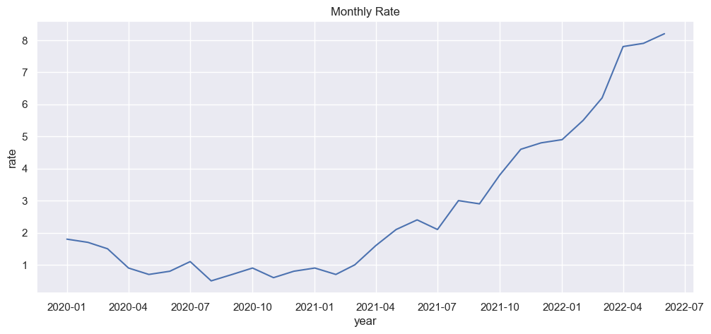

Fig 7: Annual Inflation (Monthly)

Inflation in the UK fell when the country went into lockdown and again when GDP shrank, as was predicted during the epidemic. The risk of deflation, which the UK has so far avoided, is the biggest fear with a significant reduction in GDP. Stimulating consumption would have been challenging if the UK had experienced deflation during the Covid-19 outbreak and the curfew. Low inflation rates indicate the risk of deflation persists, but rising prices may result from an expanded economy and higher consumer spending. As the UK economy relaxed regulations and put stored demand to use, inflation is another risk. Therefore, it will be essential for the Bank of England to maintain price stability in the wake of the Covid-19 outbreak. Avoiding deflation so far has been crucial to ensuring that spending rises when limitations are lifted and facilitating a smoother economic rebound.

**COMPARISON OF THE EFFECT OF COVID 19 OF THE UK AND FRANCE USING THE COVID 19 DATA AND THE STOCK DATA**

The Covid-19 data from the UK and France was collected from World Health Organization (WHO) and Financial Times Stock Exchange from Statista. Reading the dataset and separating UK and France data of new cases, cumulative cases, new death, and cumulative death of both countries. Also, reading the stock exchange of the countries and deriving the daily change of stock by using the close of the stock subtracted by the open of the stock then dividing by the close of the stock.

$$daily_change=\frac{Close-Open }{Close }$$

After the data cleaning of both data, we then join both data together of the countries checking the correlations of the data, and how each feature affects each other.

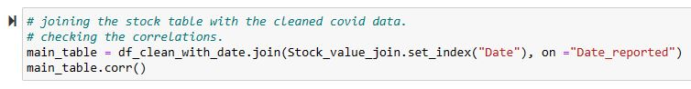

Using a preprocessing technique called ‘Normalization’ to avoid seeing a variable dominate the others because of its large values.

Creating a weight dictionary for the required feature that will affect the comparison, which is:

New cases: 1,

Cumulative cases: 0.5,

New deaths: 2,

Cumulative deaths: 1,

Daily Change: -1

Also creating a formula for it that will show the comparison of how the cases, death and stock affect each other, if the comparison is true (1) that means France was affected and if the comparison is false (0) then the UK was affected more.

$$nc_UK*1 + cc_UK*0.5 + nd_UK*2 + cd_UK*1 + change_UK*(-1) < nc_FR*1 + cc_FR*0.5 + nd_FR*2 + cd_FR*1 + change_FR*(-1)$$

nc_UK - New cases in the United Kingdom

cc_UK – Cumulative cases in the United Kingdom

nd_UK – New death in the United Kingdom

cd_UK – Cumulative death in the United Kingdom

change_UK – Daily change of stock in the United Kingdom

nc_FR - New cases in France

cc_FR – Cumulative cases in France

nd_FR – New death in France

cd_FR – Cumulative death in France

change_FR - Daily change of stock in France

Here, we employ four machine learning techniques to help in predicting the comparison outcome of the countries:

* **LOGISTIC REGRESSION**

Logistic regression is a type of supervised machine learning model used in the field of machine learning. It's also a model that tries to draw lines of demarcation between different types of groups. The predictive accuracy of our binary logistic regression model is 74%.

* **SUPPORT VECTOR MACHINE**

As a supervised machine learning algorithm, "Support Vector Machine" (SVM) can tackle both classification and regression tasks. However, its primary application is in classification issues like text classification. The model's accuracy improves to 86% when we use this kind of algorithm.

* **DECISION TREE**

Although the supervised learning technique known as the Decision Tree can be used to solve both classification and Regression issues, it is more commonly employed for the former. It's a classifier laid up like a tree, with internal nodes standing in for the features of a dataset, branches for the decision rules, and leaf nodes for the results. When we apply this kind of algorithm to the model, we achieve an accuracy of 77%.

* **RANDOM FOREST**

In the realm of supervised machine learning, random forests are quite common. In the context of machine learning, random forests are used for supervised learning when the target variable has been tagged. It's useful for both regression (with a numeric y-value as the target) and classification (with a categorical x-value as the target) scenarios. As an ensemble technique, random forests take the best predictions from multiple decision tree models and integrate them into one. A decision tree represents each of the smaller models that make up the random forest ensemble. The model's accuracy improves to 86% when we use this kind of algorithm.

From the above algorithms, we see that both the support vector machine and random forest have the same accuracy, which means we can deploy any of the highest models depending on the preferences.

**PREDICTION OF NEW CASES OF COVID 19 IN THE UNITED KINGDOM**

With the help of the previously compiled WHO Covid-19 dataset, we’ll be able to predict new cases of covid 19 and this can also be deployed for any other terminal diseases that are unforeseen. Due to daily changes in the likely outcomes of new cases, a regression model will be necessary for this type of prediction.

During this phase, we used the Random Forest Regressor and the Light Gradient Boosting Machine Regressor. Model selection for these methods also made use of Randomized Search Cross-Validation.

The RandomizedSearchCV algorithm calculates a score for a given collection of hyperparameters and then returns the best possible set of hyperparameters as the result.

**RANDOM FOREST REGRESSOR**

This algorithm combines ensemble learning techniques with the decision tree framework to generate a new result by averaging the predictions and classifications of numerous randomly generated decision trees from the data.

**Random Forest Regression Model:**

To train our random forest regression model, we will make use of the RandomForestRegressor function found in the ski-learn module. The RandomForestRegressor documentation provides a wealth of options for adjusting the model's configuration. Here are some of the more critical ones:

* **n_estimators** — the number of decision trees you will be running in the model.
* **criterion** — this variable allows you to select the criterion (loss function) used to determine model outcomes. We can select from loss functions such as mean squared error (MSE) and mean absolute error (MAE). The default value is MSE.
* **max_depth** — this sets the maximum possible depth of each tree.

Where the best parameter of the model was 'n_estimators': 1000, 'max_depth': 70 and the best accuracy score was 96% with a Mean square error of 58514528.20227057 and Root mean square of 7649.478949723998.

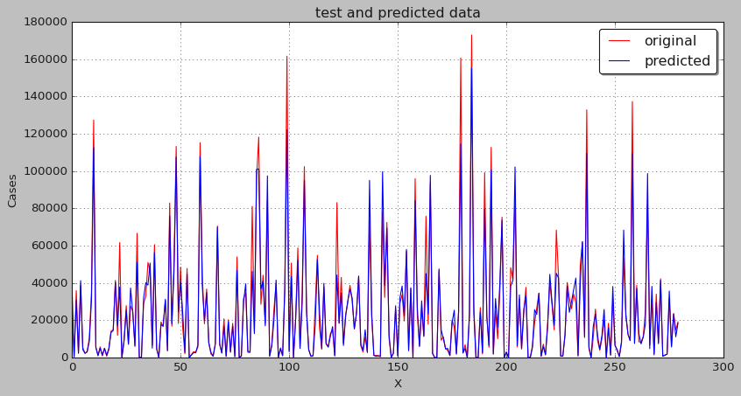

Fig 8: Test and predicted data of Random Forest regressor

**LGBM REGRESSOR**

LightGBM is a decision-tree-based gradient boosting ensemble approach used by the Train Using AutoML tool. LightGBM can be used for both classification and regression, just like other decision tree-based approaches. LightGBM was designed to function exceptionally well in distributed environments.

LightGBM is a histogram-based approach, meaning it divides the distribution of data into bins depending on the shape of the histogram. The bins are used for iteration, gain calculation, and data splitting rather than individual data points. The LGBM model mostly consists of:

* Higher accuracy and faster training speed.
* Low memory utilization
* Comparatively better accuracy than other boosting algorithms and handles overfitting much better while working with smaller datasets.
* Parallel Learning support.
* Compatible with both small and large datasets

Where the best parameter of the model 'n_estimators': 1000, 'max_depth': None, 'learning_rate': 0.1 with Mean square error of 42806688.63 and Root mean square of 6542.682067380184

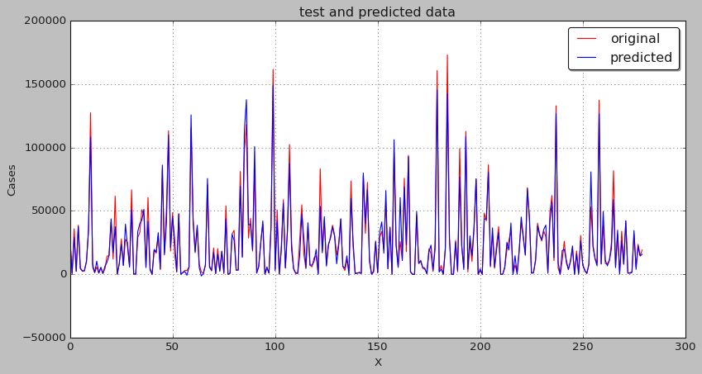

Fig 9: Test and predicted data of LGBM regressor

From the regressors above it shows that LGBM regressor has less root mean square than the Random Forest regressor, so it’s the best option to choose the LGBM regressor when deploying.

**CONCLUSION**

Quarterly GDP fell by the most on record due to the Covid-19 outbreak and the subsequent lockdown in the United Kingdom. During the Covid-19 pandemic, GDP performed worse than any other macroeconomic metric. Together, GDP and the inflation rate have dropped to levels that make deflation a real possibility. Consumers will be encouraged to spend more once the UK economy opens again if deflation is avoided.

We have developed a formula to quantify the relative impact of cases, deaths, and stocks on each country; a positive result indicates that France was hit harder than the United Kingdom, while a negative result indicates that Britain suffered more. The results suggest that France was hit harder than the UK (35%). Machine learning algorithms that can foresee the results of a comparison in the future are also built for a desirable outcome.

Finally, a machine learning regressor has enabled the prediction of future cases of Covid-19 in the UK; this will enhance the fight against any emerging diseases that could prove more lethal than Covid-19. Specifically, we use the Random forest regressor and the Light gradient boosting regressor, two machine-learning regressors. We found that the LGBM regressor performed better than the random forest regressor in terms of root mean square error. Therefore, LGBM regressor should be used anytime an organization wants to implement such a problem.

The findings of this study could be useful if another wave happens as lessons have been learnt. limitation of the study though is due to time and data constraints and we could not compare the UK to other countries with similar economics like the United States, Germany, China and Japan some of which were heavily also affected by the pandemic, this can be looked at in a future study to further sharpen my research and writing skills.

**REFERENCES**

Bank of England. (2021, April 07). How has Covid AFFECTED household savings? Retrieved April 13, 2021, from <https://www.bankofengland.co.uk/bank-overground/2020/how-hascovid-affected-household-savings>

Barro, R., Ursua, J., & Weng, J. (2020). Coronavirus meets the Great Influenza Pandemic. Retrieved December 11, 2020, from https://voxeu.org/article/coronavirus-meets-greatinfluenza-pandemic

Centers for Disease Control and Prevention (2019, June 11). 2009 H1N1 Pandemic (H1N1pdm09 virus). Retrieved December 10, 2020, <https://www.cdc.gov/flu/pandemicresources/2009-h1n1-pandemic.html>

Çongar, K. (2020) “Global economy shrank by 3%, fortunes of the rich people reached 74 trillion dollars” Euronews Ekonomi, Politika & Finans Araştırmaları Dergisi, 2020, 5(Özel Sayı): 115-136 Journal of Research in Economics, Politics & Finance, 2020, 5(Special Issue): 115-136

Ebrahimy, E., Igan, D., & Peria, S. M. (2020). The Impact of COVID-19 on Inflation: Potential Drivers and Dynamics

Gans, J. (2020). Economics in the age of COVID-19. MIT Press.

House of Commons. (2021). Interest Rates and Monetary Policy: Key Economic Indicators. Retrieved April 5, 2021, from https://commonslibrary.parliament.uk/researchbriefings/sn02802/

Keogh-Brown, M. R., Jensen, H. T., Edmunds, W. J., & Smith, R. D. (2020). The impact of Covid-19, associated behaviours and policies on the UK economy: A computable general equilibrium model. SSM - Population Health,100651. doi:10.1016/j.ssmph.2020.100651

Leslie, J., Hughes, R., McCurdy, C., Pacitti, C., Smith, J., & Tomlinson, D. (2020). Three scenarios for the impact of coronavirus on the UK economy. Retrieved October 27, 2020, from

McAuley, N. (2021, February 12a). Gross Domestic Product: Chained volume measures: Seasonally adjusted £m. Retrieved December 13, 2020, from <https://www.ons.gov.uk/economy/grossdomesticproductgdp/timeseries/abmi/pn2>

McCrae, A. (2021, February 12). Business investment in the UK: October to December 2020 provisional results. Retrieved March 22, 2021, from https://www.ons.gov.uk/economy/grossdomesticproductgdp/bulletins/businessinvestment/o ctobertodecember2020provisionalresults#business-investment-data.

Munro, F. (2021, March 19). Public sector FINANCES, UK: February 2021. Retrieved March 22, 2021, from https://www.ons.gov.uk/economy/governmentpublicsectorandtaxes/licsectorfinance/bulleti ns/publicsectorfinances/february2021.

Pandemi Yüzünden Bir Milyar İnsan, (2020, 7 July). One billion people under the threat of starvation because of the pandemic. Deutsche Well Türkçe. Retrieved from: <https://www.dw.com/tr/pandemi-y%C3%BCz%C3%BCnden-bir-milyar-insana%C3%A7l%C4%B1k-tehdidi-alt%C4%B1nda/a-54083173>

Payne, C. (2021, February 11). Coronavirus (covid-19) and consumer price INFLATION weights and prices: 2021. Retrieved April 12, 2021, from [https://www.ons.gov.uk/economy/inflationandpriceindices/articles/coronaviruscovid19and consumerpriceinflationweightsandprices/2021](https://www.ons.gov.uk/economy/inflationandpriceindices/articles/coronaviruscovid19and%20consumerpriceinflationweightsandprices/2021)

World Health Organization. (2009). WHO guide to identifying the economic consequences of disease and injury.

World Health Organization from https://apps.who.int/iris/handle/10665/137037 World Health Organization. (2020). What is a pandemic?. World Health Organization from https://www.who.int/csr/disease/swineflu/frequently_asked_questions/pandemic/en/